R Program:

1. Write a R program to create a sequence of numbers from 20 to 50 and find the mean of numbers from 20 to 60 and sum of numbers from 51 to 91.

Solu:

print("sequence of number from 20 to 50")

print(seq(20,50))

print("meanof numbers from 20 to 60")

print(mean(20:60))

print('sum of number from 51 to 91')

print(sum(51:91))

output:

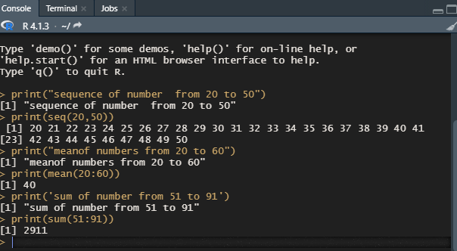

1. Write a R program to print the numbers from 1 to 100 and print "Fizz" for multiples of 3, print "Buzz" for multiples of 5, and print "FizzBuzz" for multiples of both.

Solu:

for ( n in 1:100) {

if (n %% 3 == 0 & n %% 5==0 ) {print("FizzBuzz")}

else if (n %% 3 == 0) {print("Fizz")}

else if ( n %% 5 == 0 ) {print("Buzz")}

else print(n)

}

